Geometric Tolerance (GD&T)
# Source: AI Source: Provided by: [Data Path: Persons Table -> ID Column: 1, Name_En Column: Motasem Essam] -> From: [ChatGPT] on [7/17/2026]
Geometric Tolerance, commonly known as Geometric Dimensioning and Tolerancing (GD&T), is a standardized system used to define the allowable variation in the geometry of a part. Unlike dimensional tolerances, which control only the size of a feature, GD&T controls the shape, orientation, location, profile, and runout of features to ensure that parts fit, function, and assemble correctly.
GD&T is defined by the American Society of Mechanical Engineers standard Y14.5 and the international standard ISO 1101.

Definition
# Source: AI Source: Provided by: [Data Path: Persons Table -> ID Column: 1, Name_En Column: Motasem Essam] -> From: [ChatGPT] on [7/17/2026]
Geometric Tolerance (GD&T) is a system of symbols, rules, and standards used to specify the allowable geometric variation of manufactured parts while ensuring proper function, fit, and interchangeability.

Purpose
# Source: AI Source: Provided by: [Data Path: Persons Table -> ID Column: 1, Name_En Column: Motasem Essam] -> From: [ChatGPT] on [7/17/2026]
GD&T is used to:
- Control the geometry of manufactured parts.
- Ensure proper assembly.
- Improve interchangeability.
- Reduce manufacturing costs.
- Communicate design intent clearly.
- Improve inspection consistency.
- Enhance product quality.

Why GD&T Is Needed
# Source: AI Source: Provided by: [Data Path: Persons Table -> ID Column: 1, Name_En Column: Motasem Essam] -> From: [ChatGPT] on [7/17/2026]
Traditional dimensional tolerances only specify how large or small a feature may be.
GD&T specifies:
- Whether a surface is flat.
- Whether two surfaces are parallel.
- Whether a hole is correctly positioned.
- Whether a cylinder is perfectly round.
- Whether rotating parts run smoothly.

Main Categories of Geometric Tolerances
# Source: AI Source: Provided by: [Data Path: Persons Table -> ID Column: 1, Name_En Column: Motasem Essam] -> From: [ChatGPT] on [7/17/2026]
GD&T consists of five major categories.

1. Form Tolerances
# Source: AI Source: Provided by: [Data Path: Persons Table -> ID Column: 1, Name_En Column: Motasem Essam] -> From: [ChatGPT] on [7/17/2026]
Control the shape of an individual feature.
Types include:
- Straightness
- Flatness
- Circularity (Roundness)
- Cylindricity
Example:
A surface must remain flat within 0.02 mm.

2. Orientation Tolerances
# Source: AI Source: Provided by: [Data Path: Persons Table -> ID Column: 1, Name_En Column: Motasem Essam] -> From: [ChatGPT] on [7/17/2026]
Control the orientation of one feature relative to another.
Types include:
- Parallelism
- Perpendicularity
- Angularity
Example:
A shaft must remain perpendicular to its base within 0.01 mm.

3. Location Tolerances
# Source: AI Source: Provided by: [Data Path: Persons Table -> ID Column: 1, Name_En Column: Motasem Essam] -> From: [ChatGPT] on [7/17/2026]
Control the location of features.
Types include:
- Position
- Concentricity (legacy in ASME; newer practice often prefers position or runout)
- Symmetry
Example:
A hole center must lie within a specified positional tolerance zone.

4. Profile Tolerances
# Source: AI Source: Provided by: [Data Path: Persons Table -> ID Column: 1, Name_En Column: Motasem Essam] -> From: [ChatGPT] on [7/17/2026]
Control the shape of complex surfaces.
Types include:
- Profile of a Line
- Profile of a Surface
Example:
An aircraft wing profile must remain within a tolerance band.

5. Runout Tolerances
# Source: AI Source: Provided by: [Data Path: Persons Table -> ID Column: 1, Name_En Column: Motasem Essam] -> From: [ChatGPT] on [7/17/2026]
Control rotating parts.
Types include:
- Circular Runout
- Total Runout
Example:
A rotating shaft must not wobble more than 0.01 mm.

Common GD&T Symbols
# Source: AI Source: Provided by: [Data Path: Persons Table -> ID Column: 1, Name_En Column: Motasem Essam] -> From: [ChatGPT] on [7/17/2026]
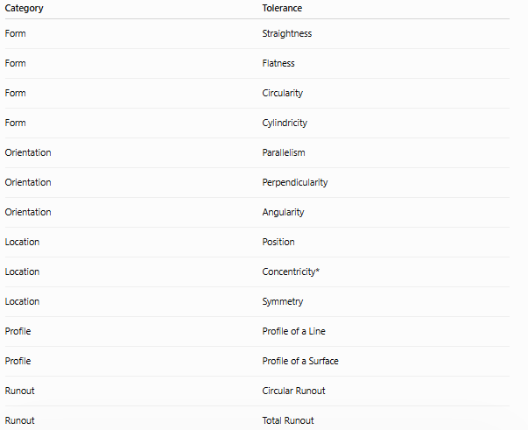
Category | Tolerance
Form | Straightness
Form | Flatness
Form | Circularity
Form | Cylindricity
Orientation | Parallelism
Orientation | Perpendicularity
Orientation | Angularity
Location | Position
Location | Concentricity*
Location | Symmetry
Profile | Profile of a Line
Profile | Profile of a Surface
Runout | Circular Runout
Runout | Total Runout
*Concentricity is included because it appears in many references, although it is used less frequently in modern ASME practice.

Datum
# Source: AI Source: Provided by: [Data Path: Persons Table -> ID Column: 1, Name_En Column: Motasem Essam] -> From: [ChatGPT] on [7/17/2026]
A datum is a theoretically exact reference point, line, axis, or plane used to establish the coordinate system from which geometric tolerances are measured.
Example:
A flat base surface may serve as Datum A.

Feature Control Frame
# Source: AI Source: Provided by: [Data Path: Persons Table -> ID Column: 1, Name_En Column: Motasem Essam] -> From: [ChatGPT] on [7/17/2026]
GD&T requirements are communicated using a feature control frame, which typically contains:
- The geometric characteristic symbol.
- The tolerance value.
- Any applicable modifiers.
- The referenced datum(s).
Example:
| Position | ⌀0.10 | A | B | C |
This indicates that the controlled feature's axis must lie within a cylindrical tolerance zone of diameter 0.10 mm, referenced to datums A, B, and C.

Examples
# Source: AI Source: Provided by: [Data Path: Persons Table -> ID Column: 1, Name_En Column: Motasem Essam] -> From: [ChatGPT] on [7/17/2026]
Flatness
A plate surface must not deviate from perfect flatness by more than 0.02 mm.

Position
A hole center must remain within a cylindrical tolerance zone of 0.05 mm relative to specified datums.

Parallelism
Two surfaces must remain parallel within 0.01 mm.

Circular Runout
A rotating shaft must not exceed the specified runout limit during one full rotation.

Applications
# Source: AI Source: Provided by: [Data Path: Persons Table -> ID Column: 1, Name_En Column: Motasem Essam] -> From: [ChatGPT] on [7/17/2026]
GD&T is widely used in:
- Mechanical engineering
- Aerospace
- Automotive engineering
- CNC machining
- Robotics
- Manufacturing
- Medical devices
- Electronics
- Precision engineering
- Industrial inspection

Advantages
# Source: AI Source: Provided by: [Data Path: Persons Table -> ID Column: 1, Name_En Column: Motasem Essam] -> From: [ChatGPT] on [7/17/2026]
GD&T:
- Clearly communicates design intent.
- Improves interchangeability.
- Reduces manufacturing cost.
- Simplifies inspection.
- Improves product quality.
- Supports automated manufacturing.

Disadvantages
# Source: AI Source: Provided by: [Data Path: Persons Table -> ID Column: 1, Name_En Column: Motasem Essam] -> From: [ChatGPT] on [7/17/2026]
- More complex than traditional tolerancing.
- Requires specialized training.
- May increase drawing complexity.
- Requires inspectors familiar with GD&T standards.

GD&T vs. Dimensional Tolerance
# Source: AI Source: Provided by: [Data Path: Persons Table -> ID Column: 1, Name_En Column: Motasem Essam] -> From: [ChatGPT] on [7/17/2026]
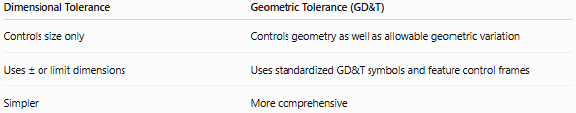
Dimensional Tolerance | Geometric Tolerance (GD&T)
Controls size only | Controls geometry as well as allowable geometric variation
Uses ± or limit dimensions | Uses standardized GD&T symbols and feature control frames
Simpler | More comprehensive

Importance
# Source: AI Source: Provided by: [Data Path: Persons Table -> ID Column: 1, Name_En Column: Motasem Essam] -> From: [ChatGPT] on [7/17/2026]
GD&T:
- Ensures proper assembly.
- Improves manufacturing consistency.
- Supports global engineering standards.
- Reduces inspection ambiguity.
- Improves reliability.
- Enables precision manufacturing.

Common Mistakes
# Source: AI Source: Provided by: [Data Path: Persons Table -> ID Column: 1, Name_En Column: Motasem Essam] -> From: [ChatGPT] on [7/17/2026]
- Confusing dimensional tolerance with geometric tolerance.
- Using unnecessary GD&T controls.
- Selecting the wrong datum.
- Misinterpreting feature control frames.
- Ignoring applicable ASME or ISO standards.

Key Points
# Source: AI Source: Provided by: [Data Path: Persons Table -> ID Column: 1, Name_En Column: Motasem Essam] -> From: [ChatGPT] on [7/17/2026]
- GD&T controls the geometry of parts, not just their size.
- It standardizes the communication of allowable geometric variation.
- It includes Form, Orientation, Location, Profile, and Runout tolerances.
- It relies on datums as reference features.
- GD&T improves fit, function, interchangeability, inspection, and manufacturing efficiency.

Conclusion
# Source: AI Source: Provided by: [Data Path: Persons Table -> ID Column: 1, Name_En Column: Motasem Essam] -> From: [ChatGPT] on [7/17/2026]
Geometric Tolerance (GD&T) is a standardized engineering system used to define the allowable variation in the geometry of manufactured parts, ensuring that components fit, function, and assemble correctly even when small manufacturing variations occur. Unlike dimensional tolerances, which control only size, GD&T controls form, orientation, location, profile, and runout using internationally recognized symbols, feature control frames, and datum references. By clearly communicating design intent, GD&T improves manufacturing consistency, product quality, interchangeability, inspection accuracy, and production efficiency, making it an essential tool in modern engineering and precision manufacturing.

